H.T No
Regulations:
A15

Sreenidhi Institute of Science and Technology
(An Autonomous Institution)
Code No: 5B414 Date: 21-Oct-2021(AN)

B.Tech II-Year II- Semester External Examination, Sept/Oct - 2021 (Supplementary)
Machine Drawing and computer aided design (ME)

Time: 3 Hours Max.Marks:75

Note: a) No additional answer sheets will be provided.
b) All sub-parts of a question must be answered at one place only, otherwise it will not be valued.
c) Missing data can be assumed suitably.

ANSWER ALL TWO QUESTIONS.

1. | a) | Draw i) the profile of ISO metric thread with proportions in terms of pitch ii) Two views of Hexagonal headed bolt with proportions in terms of diameter. | [30M]
 |  | (or)
 | b) | Draw the half sectional front view of a pin- type flexible coupling to connect two shafts of 40mm diameter. Show the proportional dimensions. | [30M]
2. |  | Assemble the parts of a screw jack shown in Fig. below and draw the full sectional front view and top view. Table below gives the details of the parts. | [45M]
 |  | 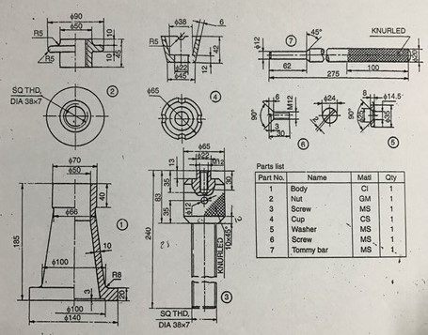

-- 00 -- 00 –

